Abstract
Faced with resource pressure in semi-arid zones, the combination of agrivoltaics (AV) and anaerobic digestion (AD) presents a transformative solution. This study develops a novel integrated optimization framework for AV-AD systems and applies it to five semi-arid locations in Burkina Faso, Türkiye, and Spain. The framework couples hourly photovoltaic modelling with the thermal energy balance of anaerobic digesters, optimizing design parameters that include panel tilt, row spacing, module height, digester volume, and PV-to heat fraction. The results demonstrate that the integrated AV-AD system achieves a Global Land Equivalent Ratio () of up to 2.66, which is 166% greater land-use efficiency compared to separate systems. For Ouagadougou, the optimal configuration (23.3° tilt, 12 m row spacing, 3.7 m module height, 72 m³ digester) maintains 100% crop yield while producing 41 kWp of PV capacity and generating 24,500 kWh/year of biomethane. Critically, only 20% of PV output is required to meet digester thermal demand, allowing full biogas utilization for revenue generation. This AV-AD synergy creates a closed-loop circular economy: solar electricity powers the digester, digestate fertilizes crops, and crop residues feed the digester. The proposed integrated system emerges as a robust, multi-output strategy to address the water-energy-food nexus in vulnerable semi-arid agroecosystems.
Keywords: Agrivoltaics; Anaerobic Digestion; Water-Energy-Food Nexus; Semi-arid Agriculture; Circular Bioeconomy; System Optimization; Land Equivalent Ratio
I. Introduction
Global population growth is exacerbating an already palpable tension on three fundamental resources: water, energy, and food. This pressure is felt most acutely in semi-arid regions. In these areas, chronic water shortages and blistering temperatures act as constant bottlenecks for agricultural output [1, 2, 3]. At the same time, we cannot ignore the agri-food sector's role in global emissions; electricity consumption alone accounts for 78.7% of its carbon footprint [4].
Although solar photovoltaic (PV) technologies offer a major pathway for the decarbonization of energy systems, their deployment has long been limited by competition for land use, as large ground-mounted solar installations often require land that would otherwise be used for food production [1, 2, 3, 5, 6]. This tension is particularly evident in densely populated regions.
For farmers in semi-arid regions, climatic conditions are characterized by a triple burden: intense sunlight, high evapotranspiration, and persistent heat waves. These factors exacerbate the pressure on water resources and create a context in which agrivoltaic (AV) solutions prove particularly relevant [7, 8]. Agrivoltaics (AV) has surfaced as a compelling "dual-use" solution to this problem, allowing crops and solar energy to share the same footprint. Research indicates that the partial shade from PV modules is a benefit-it cuts down on water loss, boosts water use efficiency (WUE), and shields crops from heat stress [4, 8, 9, 10]. Consequently, AV is increasingly seen as a practical fix for the water–energy–food nexus in drylands [1, 3, 5, 7].
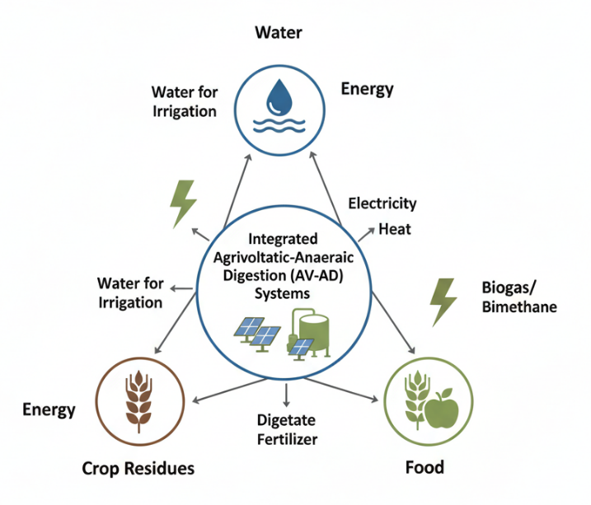
Figure 1 : Conceptual representation of the water–energy–food nexus in semi-arid regions supported by integrated agrivoltaic and anaerobic digestion systems
At the core of this approach lies the concept of synergy: instead of allowing energy production to displace agriculture, the aim is to jointly refine crop productivity and power generation. Indicators such as the land equivalence ratio (LER) consistently show the spatial advantage of this approach, with values ranging between 1.2 and 1.5, with maximums reaching 1.94 for certain crops and architectures [11, 12].
These results suggest that a co-located system can outperform the simple sum of its parts. Beyond simple land-sharing, coupling agrivoltaic systems with anaerobic digestion (AD) enables the creation of a circular energy framework that strengthens the dual-use concept.

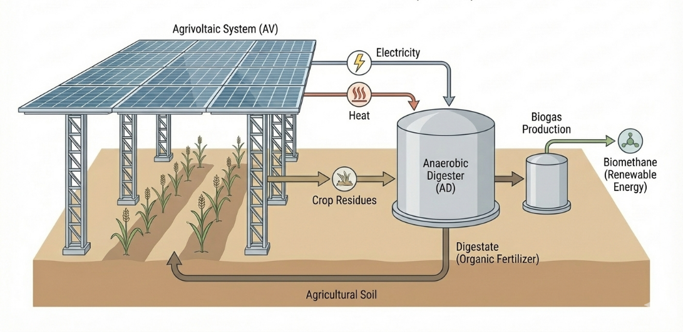
Figure 2 : Schematic representation of the integrated agrivoltaic–anaerobic digestion (AV–AD) system operating in a closed-loop configuration.
This synergy works through several mechanisms. The electricity produced by AV installations can be used to power the electrical and thermal needs of AD installations, particularly when they are supported by shallow geothermal heat pumps (GWHP)[13]. Using solar energy to power the digestion of thermal needs means we can upgrade a larger share of biogas into high value biomethane. This synergy closes the loop: crop residues become feedstock for the digester, and the resulting nutrient-rich digestate is applied back to the soil, completing a circular resource cycle [1]. In addition to mitigating land-use conflicts, this approach enhances farm resilience and diversifies income sources under changing climatic conditions. However, despite the potential, research gaps are still. Most studies still look at agricultural output or solar performance in isolation, often overlooking these complex, multi-energy configurations [14].
Three gaps justify the need for a comprehensive review. First, there is a lack of integrated optimization frameworks capable of jointly evaluating agrivoltaic architectures, particularly solar tracking systems, and anaerobic digestion units with the explicit goal of maximizing biomethane production [13]. Second, although dynamic AV systems (single- or dual-axis tracking) are particularly relevant in semi-arid climates due to their ability to modulate shading, preserve soil moisture, and mitigate photoinhibition [2, 7, 11], systematic evaluations of their performance in semi-arid conditions remain scarce [1, 3, 7]. Third, preliminary techno-economic studies suggest that using electricity generated by AVs to power the thermal load of the digester can increase the net present value (NPV) by up to a factor of 8.7 compared to conventional systems [15], but rigorous comparative analyses are still lacking. Beyond the literature on AVs, broader studies highlight the strategic importance of integrating AVs and AD into a unified agro-energy platform.
II. Agrivoltaics (AV): A Response to Climate Stress
Agrivoltaics, defined as the co-location of photovoltaic systems and agricultural activities, extends beyond electricity generation to serve as an effective strategy for climate adaptation.
II.1. Agrivoltaic architectures and design principles
Agrivoltaic (AV) systems are based on the spatial integration of photovoltaic modules and agricultural crops on the same plot of land to simultaneously optimize energy production and agricultural productivity [1, 4, 7]. Three structural dimensions determine their configuration:
(i) the installation structure (inter-row, overhead systems, photovoltaic greenhouses),
(ii) the mobility of the modules (fixed structures, single-axis, or dual-axis trackers),
(iii) the photovoltaic technology used (opaque, bifacial, semi-transparent) [4].
Despite the availability of advanced PV technologies, the simplicity and lower upfront cost of fixed-tilt systems still drive their widespread adoption. That said, solar trackers offer much higher potential; by tilting to follow the sun, they maximize power output while allowing for "active" shade management [2, 7, 11, 13]. While single-axis trackers offer a solid middle ground, dual-axis versions capture the most energy-though they come with higher mechanical costs. There is also the potential of bifacial modules, which capture light bouncing off the ground, an approach that can hike up energy yields by as much as 25% depending on the surface albedo [3, 4]. Transparent solar photovoltaic (STPV) modules add another layer of synergy, letting through the light needed for photosynthesis (PAR) while converting the rest into electricity [4].
II.2. Shading, microclimate, and agronomic performance
Shading is the main mechanism of interaction between the photovoltaic system and crops, directly influencing the distribution of PAR radiation and microclimatic dynamics [7, 8]. The actual drop in PAR is not fixed; it varies significantly based on how the system is laid out-from the specific geometry of the modules to their installation height and overall array density. Because of these variables, reported light reduction varies wildly, from a negligible 11% to a significant 95% [16].
Dynamic solar monitoring systems allow shading to be modulated by adjusting the angle of incidence of light to meet the physiological needs of crops throughout the day or seasons [2, 7, 10]. In addition to light control, AV systems also change microclimatic conditions:
- Decrease in soil temperature from -1.3°C to -2.3°C,
- Slight increase in relative humidity (approximately +2%),
- Substantial reduction in irrigation requirements (16% to 21% depending on the study) [8, 11, 19].

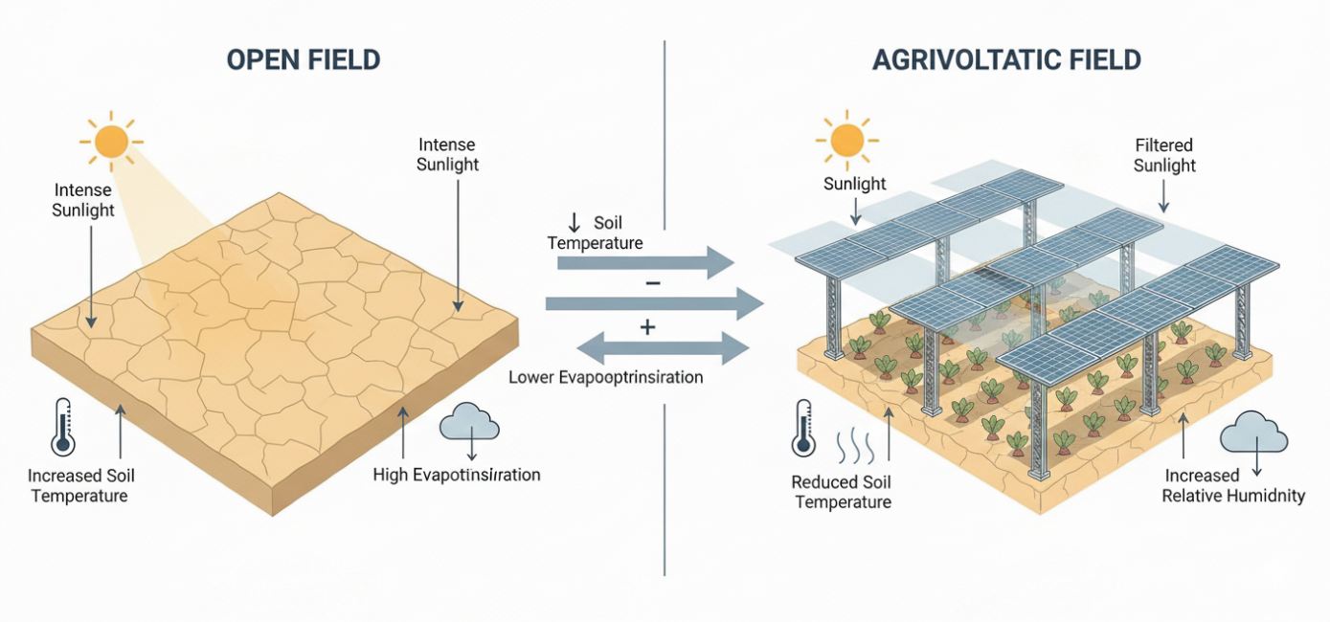
Figure 3 : Microclimate modification induced by agrivoltaic systems compared to open-field cultivation.
These shifts in the microclimate lead to better water efficiency and less heat stress for plants. In many instances, crop yields hold steady or even improve, even if there is a slight dip in the reversible active water (RAW).
III. Anaerobic Digestion (AD)
Anaerobic digestion serves as a critical platform for resource valorization and energy dispatchability within an integrated agro-energy system. In practice, AD converts agricultural residues and livestock waste into a storable energy source (biogas) and digestate, a valuable amendment for the crops [20]. The functional integration of AD with Agrivoltaics (AV) is driven by a natural synergy: while AD closes the nutrient loop, AV provides the energetic and spatial stability required to optimize the digestion process [15].
III.1. Thermal Stabilization and Energy Dispatchability
The primary function of AD in a hybrid system is to transform intermittent solar energy into reliable, 24/7 baseload power [15, 21]. However, this reliability hinges entirely on the ability to maintain stable internal temperatures. AD reactors, particularly those operating under mesophilic (37 ± 1 °C) or thermophilic (52 ± 1 °C) conditions, require strict thermal stability [22]. Even minor fluctuations can destabilize the sensitive methanogenic microbial communities, triggering immediate process inhibition and a buildup of volatile fatty acids (VFA) [22]. This challenge is especially pronounced in cold and arid climates, where significant heat loss often compromises the stability of biogas production [20, 23].
A synergistic approach consists of using electricity and thermal energy generated by the agrivoltaic system to meet the digester’s heat demand, thereby reducing reliance on biogas combustion [15]. This integration generates significant benefits:
Biomethane Savings: Solar thermal integration can save up to 30-40% of the biogas typically consumed for digester self-heating in cold temperate climates. In semi-arid climates, where heating needs are lower, but sunshine is high, this saving can be converted into a surplus of usable biomethane, improving the system's net product value (NPV) [9].
System Sizing Reduction: A rigorously modeled constant-temperature digester (maintained at 39°C) significantly reduces the required sizing of intermittent energy components. Integrated heating has been shown to reduce the necessary Photovoltaic (PV) and Energy Storage System (ESS) sizes by 65% and 52%, respectively, compared to conventional non-heated PV-biogas systems [15].
Operational Resilience: Adaptive operational strategies further enhance stability. Pilot studies in cold and arid areas have demonstrated the feasibility of seasonal thermal switching, allowing stable operation at 26°C in winter/spring and switching to optimal mesophilic (37°C) or thermophilic (52°C) conditions in summer, leveraging solar abundance [23].
III.2. Feedstock Management and Bioconversion Kinetics
The second challenge in harmonizing AV and AD lies in managing the heterogeneous biomass generated by agricultural activities. The substantial variability in methane yields measured by Biochemical Methane Potential (BMP) tests directly reflects the diverse chemical composition and inherent biodegradability of agricultural substrates. Typical yields for cattle manure, cereal straw, and mixed vegetable residues range between 200 and 400 NmLCH₄/g VS (Table 1), illustrating the need for substrate-specific modeling in integrated AV–AD systems.
Agricultural residues often present kinetic difficulties, which can lead to friction in the integrated system:
Residue Characteristics: Many crop residues have a high C/N ratio and high lignocellulosic content, which is resistant to hydrolysis and can slow down the overall AD process [22, 23]. The high C/N ratio inherent in some arid residues, such as date palm waste, leads to low rates of nitrogen mineralization, potentially necessitating composting periods of up to 270 days to reach stability [23].
Co-digestion as Mitigation: To overcome these kinetic constraints, anaerobic co-digestion (AcoD) is often mandatory [22]. AcoD involves mixing AV residues (the carbon source) with N-rich waste streams (e.g., animal manure or food waste) to balance the C/N ratio and dilute potential inhibitors.
Precision Modeling and Synergies: The efficiency of substrate mixing is commonly assessed using Biochemical Methane Potential (BMP) tests [24]. For instance, combining multiple tomato residues achieved a maximum BMP of $324 \left(NmLCH_{4}\right).{(gVS) }^{-1}$ when the highly lignocellulosic branches were kept below 20% of the mixture, demonstrating a synergistic co-digestion performance index of approximately 1.20. Predictive tools such as the Modified Gompertz model and the ADM1 framework are essential for accurately describing and forecasting anaerobic digestion behavior. They allow us to optimize these blends and anticipate kinetic failures by monitoring vital indicators like the Volatile Fatty Acids to Alkalinity ($VFA/Alk$) ratio [21, 22]. The Modified Gompertz model is given following this relation:
$$\begin{aligned}M\left(t\right)= P *\exp\left\{-\exp\left[\left(R_{max}* \frac{e}{P}\right)* \left(λ - t\right)+ 1\right]\right\} \#\left(1\right)\end{aligned}$$
Where
- $M(t)$ : Cumulative methane production at time t (NmL/gVS)
- $P$ : Ultimate methanogenic potential (BMP)
- $R_{max}$ : Maximum methane production rate
- $λ$ : Latency
- $e$: exp(1)
Table 1 : Methanogenic potential (BMP) of agricultural substrates
Substrate | BMP (NmLCH₄/g VS) | Sources
Cattle manure | ~200–280 | [25]
Cereal straw | ~230–320 | [26]
Vegetable and fruit residues | ~200–400 | [25]
Tomato /crop residues | ~250–350 | [25]
Poultry manure/effluent | ~210–289 | [27]
Equine manure | ~170–220 | [28]

III.3. Digestate and the Synergistic Agronomic Loop
The final component of the synergy is the role of digestate (DG), the nutrient-rich effluent from the AD process, in enhancing the resilience of the AV field.
Beyond being just a byproduct, DG serves as a potent bio-fertilizer. It returns essential N, P, and K to the land, along with a rich profile of micronutrients and organic matter that revitalizes the soil. Crucially, DG addresses the primary constraint of semi-arid agriculture-water scarcity by improving soil structure. The application of digestate significantly reduces soil bulk density, improving porosity, and enhancing water infiltration and retention capacity [23].
This effect is highly synergistic with the AV microclimate. While the AV panels reduce water loss by minimizing solar exposure and evapotranspiration, the DG simultaneously enhances the soil's intrinsic ability to store the remaining water [23]. This double action maximizes the overall water-use efficiency (WUE) and resource security of the integrated system [1].
IV. Methodology
This study employs an integrated system modeling approach that combines photovoltaic energy simulation with anaerobic digestion modeling under the climatic constraints of semi-arid regions.
IV.1. Site Characterization and Climate Data
The simulation is based on a typical “semi-arid” climate profile characterized by high solar radiation and seasonal water deficits.
- Meteorological data: Hourly data (Global Horizontal Irradiation - GHI, ambient temperature, precipitation) are extracted from PVGIS-SARAH satellite databases.
- Stress criteria: The focus is on the summer months when potential evapotranspiration ($ET_{0}$) exceeds precipitation, creating a critical need for irrigation and panel cooling.
IV.2. Photovoltaic (PV) Conversion Modeling
Accurate modeling of megawatt-scale hybrid systems requires precise sizing of PV panels. This is often achieved using sophisticated models such as the double-diode (DD) model [21]. The output power, $P_{PV}$, depends on the received irradiance and the cell temperature.
$\begin{aligned}P_{PV}=P_{STC}\frac{G_{front}+(G_{rear}*ρ*(1-η_{loss})}{1000}\left[1+β_{p}*\left(T_{cell}-25\right)\right]\#\left(2\right)\end{aligned}$
$$\begin{aligned}T_{cell}= T_{amb}+ \left(\frac{G_{eff}}{G_{NOCT}}\right)* \left(T_{NOCT}- T_{amb_{20}}\right)\#\left(3\right)\end{aligned}$$
Where
- $P_{STC}$: Peak power under standard conditions.
- $G_{front}$; $G_{rear}$: Irradiance on the front and rear surfaces (W/m²).
- $ρ$: Bifaciality factor of the module.
- $β_{p}$: Power temperature coefficient.
- $T_{cell}$: Cell temperature.
- $G_{eff}$ : Effective irradiance on the module.
- $T_{NOCT}$ : Nominal operating temperature of the cell (usually 45±2°C).
- $T_{amb_{20}}$ : 20°C.
The specific challenge for AV lies in determining the incident solar radiation (G) reaching the cell and the ground. Accurate sizing requires modeling key variables like solar position, panel orientation (tilt and azimuth), and shading geometry. In more confined structures, such as PV greenhouses, this incident radiation has a direct impact on internal heat balances, potentially increasing the internal temperature and affecting humidity [29].
IV.3. Evapotranspiration (ET) : Penman-Monteith FAO-56
Evapotranspiration (ET) is the main flow of water from the soil surface and canopy to the atmosphere. To model the impact of APV on irrigation requirements, the Penman-Monteith equation, formulated by the FAO (FAO-56), is the standard and validated method for calculating reference evapotranspiration ($ET_{0}$) [30]. This equation incorporates all the parameters that govern energy exchange and latent heat flux [30].
The Penman-Monteith equation is expressed as:
$$\begin{aligned}{ET}_{0}=\frac{0.408*∆*\left(R_{n}-G\right)+γ*\frac{C_{n}}{T+273}*u_{2}*\left(e_{s}-e_{a}\right)}{∆+γ*\left(1+C_{d}{*u}_{2}\right)}\#\left(4\right)\end{aligned}$$
Where the physical and climatological terms are:
- ${ET}_{0}$: Reference evapotranspiration ($mm {day}^{-1} or h^{-1}$) ;
- $R_{n}$: Net radiation at the surface of the reference crop (${MJm}^{-2}{day}^{-1})$;
- $G$: Ground heat flow (${MJm}^{-2}{day}^{-1})$;
- $∆$ : Slope of the vapor pressure curve (${kPA°C}^{-1})$;
- $γ$ : Psychrometric constant (${kPA°C}^{-1})$;
- $u_{2}$ : Wind speed at two (02) meters $({m.s}^{-1})$;
- $T$: Average air temperature $(°C)$;
- $(e_{s}-e_{a}$): Vapor pressure deficit (kPa);
- $C_{n}$ et $C_{d}$ are constant coefficients depending on the calculation period (daily or hourly).
The actual evapotranspiration of crops $ET_{c}$ is then calculated using the crop coefficient ($K_{c}$):
$$\begin{aligned}{ET}_{c}= K_{c}*{ET}_{0}\#\left(5\right)\end{aligned}$$
The integration of an AV system fundamentally alters the hydro-climatological environment. Experimental research, particularly using lysimeters, confirms that ET rates under PV systems are significantly lower than in open plots [31]. This observed reduction stems primarily from the shading by PV panels, which curtails direct solar exposure and promotes higher soil moisture [31]. To capture this effect in a model, the adaptation of the Penman-Monteith equation focuses on modifying its core energy balance term: net radiation (Rₙ). A geometric shading factor ($F_{shad}$) is introduced to quantify the fraction of direct and diffuse solar radiation blocked by the panels at a given time $t$ :

$$\begin{aligned}R_{n,APV}=R_{n,open}*\left(1-F_{shad}\right) \#\left(6\right)\end{aligned}$$$${}_{1_{5}}^{}{}$$
Where $R_{n,open}$ represents net radiation without panels. This formalism captures the observed physical impact and becomes the basis for quantifying the water savings achievable by the system, thus contributing to sustainable water management objectives, particularly in arid and semi-arid regions [31].
It is also crucial to consider that shading and environmental modification can alter the surface resistance and aerodynamics of the canopy, which may require calibration or redefinition of the crop coefficient $K_{c}$ for the specific crop under the panels [30].
IV.4. Performance indicators
The performance of AV systems is assessed using indicators that combine energy efficiency and agricultural productivity.
- Land-energy ratio (LER)
$$\begin{aligned}Y_{PAR,AV}=\frac{1}{{PAR}_{Th}}\int_{0}^{t}{PAR\left(x,t\right).dt}\#\left(7\right)\end{aligned}$$
Here, $PAR_{Th }$ denotes the crop-specific photosynthetic saturation threshold and represents the fraction of incoming radiation effectively used for photosynthesis [11].

- Light productivity factor (LPF)
$$\begin{aligned}LPF=Y_{PAR}+Y_{PV}\#\left(8\right)\end{aligned}$$
This indicator summarizes the joint performance of the system, considering crop light productivity and photovoltaic productivity [11].
IV.5. Mathematical Formalism of the Anaerobic Digestion (AD) and Biogas Subsystem
Modeling the anaerobic digestion subsystem is essential to ensure stable and predictable biogas production, a major asset in compensating for the intermittency of renewable energy sources (RES).
IV.5.1. Stoichiometric Modeling and Energy Input Potential
The chemical basis of anaerobic digestion is the conversion of organic matter (OM) in the presence of heat and in the absence of oxygen [20]:
$$\begin{aligned}OM+Heat → {CH}_{4}+{CO}_{2}+H_{2}O+Energy \#\left(9\right)\end{aligned}$$
Most of the energy produced is stored in the form of methane (CH₄) [20]. A substrate Biochemical Methane Potential (BMP) quantifies its practical methane yield, while the Theoretical Methane Yield (TMY) provides a stoichiometric upper limit based on its chemical formula. Degradability is thus formalized [24] :
$$\begin{aligned}Degradability\left(\%\right)= \frac{BMP}{TBMP}*100\%\#\left(10\right)\end{aligned}$$
This ratio quantifies the maximum efficiency of the process, thereby figuring out the size of the upstream biogas system.
IV.5.2. Kinetic Modeling and Stability Factors
Kinetic models (often based on Anaerobic Digestion Model No. 1 - ADM1) describe the successive stages of hydrolysis, acidogenesis, acetogenesis, and methanogenesis, thereby linking reaction rates to methane yield [22].
Operational stability is a key factor in kinetic modeling. The model must incorporate retention time constraints. A key operational constraint is supporting a solid retention time (SRT) that sufficiently exceeds the hydraulic retention time (HRT) to prevent the washout of the critical, slow-growing methanogenic consortium. In addition, kinetic modeling provides early warning indicators for process control. The most reliable indicator in practice is the Volatile Fatty Acids to Alkalinity ratio (VFA/Alk). Stable operation is associated with VFA/Alk ratios below 0.3 and methane contents between 50% and 70% (v/v) in the biogas [22].
IV.5.3. Digester Heat Balance
Biogas production is strongly influenced by temperature, particularly under mesophilic operating conditions (35-40°C). To obtain a constant biogas output, which is a requirement for reliable integration into a hybrid energy system, it is essential to maintain a stable digester temperature ($T_{Dig}$), for example at 39°C [15].
The thermal model is the gateway between the biological subsystem and the energy subsystems (PV/ESS) that can provide heating energy. The model computes hourly heat requirements (${\dot{Q}}_{heat}$) to offset thermal losses and keep energy balance within the system.
The general equation for the Digester Energy Balance is as follows:
$$\begin{aligned}{\dot{Q}}_{heat}= {\dot{Q}}_{stored}+{\dot{Q}}_{loss}-{\dot{Q}}_{in flow}-{\dot{Q}}_{reaction}\#\left(11\right)\end{aligned}$$
$$\begin{aligned}{\dot{Q}}_{loss}= {\dot{Q}}_{{loss}_{cond}}+{\dot{Q}}_{{loss}_{evap}}\#\left(12\right)\end{aligned}$$
$$\begin{aligned}{\dot{Q}}_{loss_{cond}}= U * A*\left(T_{dig}- T_{amb}\right)\#\left(13\right)\end{aligned}$$
$$\begin{aligned}{\dot{Q}}_{loss_{evap}}= h_{evap}* A * \left(P_{vap},sat\left(T_{dig}\right)- RH * P_{vap},sat\left(T_{amb}\right)\right)\#\left(14\right)\end{aligned}$$
$$\begin{aligned}{\dot{Q}}_{in_{flow}}= ṁ_{substrate}* Cp_{substrate}* \left(T_{substrate}- T_{ref}\right)\#\left(15\right)\end{aligned}$$
Where:
- ${\dot{Q}}_{heat }$ Represents the heat flow required by the heating system (from biogas cogeneration or other renewable energy sources).
- ${\dot{Q}}_{stored}$is the change in internal energy stored in the volume of the digester.
- ${\dot{Q}}_{loss}$is the heat flow lost through conduction, convection, and evaporation, which depends directly on typical meteorological year (TMY) data and digester geometry.
- ${\dot{Q}}_{in flow}$ and ${\dot{Q}}_{reaction}$ are respectively the heat flows provided by the incoming substrate and the heat generated or consumed by biological reactions [15].

IV.6. Overall Performance Indicator
This is the final equation that proves the efficiency of the integrated system with an integrated LER (Land Equivalent Ratio) that includes the biogas component.
$$\begin{aligned}{LER}_{Global} =\frac{Y_{crop\left(AV\right)}}{Y_{crop\left(open\right)}}+\frac{Y_{PV\left(AV\right)}}{Y_{PV\left(open\right)}}+\frac{Y_{Biogas}}{Y_{Ref,Biogas}} \#\left(16\right)\end{aligned}$$
Where:
- $\frac{Y_{crop\left(AV\right)}}{Y_{crop\left(open\right)}}$: Agricultural yield ratio (under cover cultivation/open field cultivation).
- $\frac{Y_{PV\left(AV\right)}}{Y_{PV\left(open\right)}}$: Solar power generation ratio.
- $\frac{Y_{Biogas}}{Y_{Ref,Biogas}}$: represents the energy recovery from agricultural waste on the same surface area, transforming waste into energy. $Y_{Ref,Biogas}$ represents the maximum theoretical energy potential (in MJ/ha/year) that could be obtained if all the biomass produced on the plot (including inedible residues) were digested in a separate and ideal AD unit, without any spatial integration constraints with the PV. It serves as a basis for comparison for the efficiency of AV-AD spatial coupling.

Conclusion
Through this analysis, it becomes clear that the integration of agrivoltaics and anaerobic digestion holds transformative potential for semi-arid regions. Far from being merely co-located, these technologies interact synergistically to create a system that is greater than the sum of its parts.
The AV component provides a dual service: producing renewable electricity while creating a favorable microclimate that conserves water and protects crops. The AD component adds critical circularity and dispatchability, transforming waste into energy and returning vital nutrients to the soil via digestate. Crucially, the linkage between them, where solar energy ensures the digester's thermal stability, unlocks higher efficiency and economic value, moving beyond simple energy substitution towards true resource symbiosis.
This integrated model directly tackles the core challenges of the water-energy-food nexus. It increases land-use efficiency (as quantified by the enhanced Land Equivalent Ratio), fortifies water security by combining reduced evapotranspiration with improved soil water retention, and diversifies farm revenue through the sale of electricity, biomethane, and potentially premium crops. While challenges remain in system optimization, feedstock management, and site-specific adaptation, the AV-AD synergy offers a compelling, scalable blueprint for sustainable intensification. It represents a pragmatic step towards climate-resilient agriculture that produces both food and energy without compromising vital resources, making it a vital strategy for the future of semi-arid regions.

References:
[1] K. Proctor, G. Murthy, and C. Higgins, “Agrivoltaics Align with Green New Deal Goals While Supporting Investment in the US’ Rural Economy,” Sustainability, vol. 13, no. 1, p. 137, Dec. 2020, doi: 10.3390/su13010137.
[2] H. Imran, M. H. Riaz, and N. Z. Butt, “Optimization of Single-Axis Tracking of Photovoltaic Modules for Agrivoltaic Systems,” in 2020 47th IEEE Photovoltaic Specialists Conference (PVSC), Calgary, AB, Canada: IEEE, June 2020, pp. 1353–1356. doi: 10.1109/PVSC45281.2020.9300682.
[3] A. Sarr, Y. M. Soro, A. K. Tossa, and L. Diop, “Agrivoltaic, a Synergistic Co-Location of Agricultural and Energy Production in Perpetual Mutation: A Comprehensive Review,” Processes, vol. 11, no. 3, p. 948, Mar. 2023, doi: 10.3390/pr11030948.
[4] S. Gorjian et al., “Progress and challenges of crop production and electricity generation in agrivoltaic systems using semi-transparent photovoltaic technology,” Renewable and Sustainable Energy Reviews, vol. 158, p. 112126, Apr. 2022, doi: 10.1016/j.rser.2022.112126.
[5] J. Macknick et al., “The 5 Cs of Agrivoltaic Success Factors in the United States: Lessons from the InSPIRE Research Study,” NREL/TP-6A20-83566, 1882930, MainId:84339, Aug. 2022. doi: 10.2172/1882930.
[6] D. Ketzer, N. Weinberger, C. Rösch, and S. B. Seitz, “Land use conflicts between biomass and power production – citizens’ participation in the technology development of Agrophotovoltaics,” Journal of Responsible Innovation, vol. 7, no. 2, pp. 193–216, May 2020, doi: 10.1080/23299460.2019.1647085.
[7] M. Reasoner and A. Ghosh, “Agrivoltaic Engineering and Layout Optimization Approaches in the Transition to Renewable Energy Technologies: A Review,” Challenges, vol. 13, no. 2, p. 43, Sept. 2022, doi: 10.3390/challe13020043.
[8] S. Mohammedi, G. Dragonetti, N. Admane, and A. Fouial, “The Impact of Agrivoltaic Systems on Tomato Crop: A Case Study in Southern Italy,” Processes, vol. 11, no. 12, p. 3370, Dec. 2023, doi: 10.3390/pr11123370.
[9] M. Temiz, N. Sinbuathong, and I. Dincer, “Development and assessment of a new agrivoltaic‐biogas energy system for sustainable communities,” Intl J of Energy Research, vol. 46, no. 13, pp. 18663–18675, Oct. 2022, doi: 10.1002/er.8483.
[10] T. Semeraro et al., “Shading effects in agrivoltaic systems can make the difference in boosting food security in climate change,” Applied Energy, vol. 358, p. 122565, Mar. 2024, doi: 10.1016/j.apenergy.2023.122565.
[11] M. H. Riaz, H. Imran, H. Alam, M. A. Alam, and N. Z. Butt, “Crop-Specific Optimization of Bifacial PV Arrays for Agrivoltaic Food-Energy Production: The Light-Productivity-Factor Approach,” IEEE J. Photovoltaics, vol. 12, no. 2, pp. 572–580, Mar. 2022, doi: 10.1109/JPHOTOV.2021.3136158.
[12] D. Mazzeo, A. Di Zio, C. Pesenti, and S. Leva, “Optimizing Agrivoltaic Systems: A Comprehensive Analysis of Design, Crop Productivity and Energy Performance in Open-Field Configurations,” 2025, SSRN. doi: 10.2139/ssrn.5082169.
[13] A. Ravilla, G. Shirkey, J. Chen, M. Jarchow, O. Stary, and I. Celik, “Techno-economic and life cycle assessment of agrivoltaic system (AVS) designs,” Science of The Total Environment, vol. 912, p. 169274, Feb. 2024, doi: 10.1016/j.scitotenv.2023.169274.
[14] A. Chalgynbayeva, Z. Gabnai, P. Lengyel, A. Pestisha, and A. Bai, “Worldwide Research Trends in Agrivoltaic Systems—A Bibliometric Review,” Energies, vol. 16, no. 2, p. 611, Jan. 2023, doi: 10.3390/en16020611.
[15] A. Pal and G. S. Ilango, “Design and techno-economic analysis of an off-grid integrated PV-biogas system with a constant temperature digester for a cost-effective rural application,” Energy, vol. 287, p. 129671, Jan. 2024, doi: 10.1016/j.energy.2023.129671.
[17] S. Zainali et al., “Direct and diffuse shading factors modelling for the most representative agrivoltaic system layouts,” Applied Energy, vol. 339, p. 120981, June 2023, doi: 10.1016/j.apenergy.2023.120981.
[19] R. Waller, M. Kacira, E. Magadley, M. Teitel, and I. Yehia, “Semi-Transparent Organic Photovoltaics Applied as Greenhouse Shade for Spring and Summer Tomato Production in Arid Climate,” Agronomy, vol. 11, no. 6, p. 1152, June 2021, doi: 10.3390/agronomy11061152.
[20] D. W. Hamilton, “Oklahoma Cooperative Extension Service”.
[21] H. M. K. Al-Masri, A. A. Al-Sharqi, S. K. Magableh, A. Q. Al-Shetwi, M. G. M. Abdolrasol, and T. S. Ustun, “Optimal Allocation of a Hybrid Photovoltaic Biogas Energy System Using Multi-Objective Feasibility Enhanced Particle Swarm Algorithm,” Sustainability, vol. 14, no. 2, p. 685, Jan. 2022, doi: 10.3390/su14020685.
[22] K. Pilarski and A. A. Pilarska, “Kinetics and Energy Yield in Anaerobic Digestion: Effects of Substrate Composition and Fundamental Operating Conditions,” Energies, vol. 18, no. 23, p. 6262, Nov. 2025, doi: 10.3390/en18236262.
[23] A. Ouali, F. Hiouani, K. Beribeche, and D. Madani, “Optimized date palm waste composting: Accelerating maturity via C:N ratio and moisture adjustments using a rotary drum system,” J. Ecol. Eng., vol. 26, no. 8, pp. 120–131, Aug. 2025, doi: 10.12911/22998993/203810.
[24] L. Feng et al., “Biochemical Methane Potential (BMP) of Vinegar Residue and the Influence of Feed to Inoculum Ratios on Biogas Production,” BioResources, vol. 8, no. 2, pp. 2487–2498, Mar. 2013, doi: 10.15376/biores.8.2.2487-2498.
[25] A. Lallement et al., “A Detailed Database of the Chemical Properties and Methane Potential of Biomasses Covering a Large Range of Common Agricultural Biogas Plant Feedstocks,” Waste, vol. 1, no. 1, pp. 195–227, Jan. 2023, doi: 10.3390/waste1010014.
[26] “AGIR BIOGAZ - Les substrats en méthanisation,” AILE. Accessed: Dec. 22, 2025. [Online]. Available: https://aile.asso.fr/biogaz/ressources-outils/les-substrats/
[27] “Intrants (ou gisements) de la méthanisation,” Triple Performance. Accessed: Dec. 22, 2025. [Online]. Available: //wiki.tripleperformance.fr/wiki/Intrants_(ou_gisements)_de_la_m%C3%A9thanisation
[28] P. D.-V. HUBERT;, “Caractéristiques du fumier équin pour la méthanisation.” Accessed: Dec. 22, 2025. [Online]. Available: https://equipedia.ifce.fr/infrastructure-et-equipement/installation-et-environnement/effluents-delevage/caracteristiques-du-fumier-equin-pour-la-methanisation
[29] M. E. Evans, J. A. Langley, F. R. Shapiro, and G. F. Jones, “A Validated Model, Scalability, and Plant Growth Results for an Agrivoltaic Greenhouse,” Sustainability, vol. 14, no. 10, p. 6154, May 2022, doi: 10.3390/su14106154.
[30] “Chapter 2 - FAO Penman-Monteith equation.” Accessed: Dec. 22, 2025. [Online]. Available: https://www.fao.org/4/x0490e/x0490e06.htm
[31] M. Tawassulli, “EVAPOTRANSPIRATION IN AGRIVOLTAIC ENVIRONMENT: A FIELD STUDY”.

